| **BASIS OF COMPARISON** | **LAN** | **MAN** | **WAN** |
| --- | --- | --- | --- |
| Expands to | Local Area Network | Metropolitan Area Network | Wide Area Network |
| Meaning | A network that connects a group of computers in a small geographical area. | It covers relatively large region such as cities, towns. | It spans large locality and connects countries together. Example Internet. |
| Ownership of Network | Private | Private or Public | Private or Public |
| Design and maintenance | Easy | Difficult | Difficult |
| Propagation Delay | Short | Moderate | Long |
| Speed | High | Moderate | Low |
| Fault Tolerance | More Tolerant | Less Tolerant | Less Tolerant |
| Congestion | Less | More | More |
| Used for | College, School, Hospital. | Small towns, City. | Country/Continent. |

**hat is the Difference between Connection-Oriented and Connectionless Services of the Protocols?**

|  |  |  |
| --- | --- | --- |
| **Protocol Characteristics** | **Connection Oriented Protocol Sevices** | **Connectionless Protocol Sevices** |
| **1) Definition** | It is the communication service in which virtual connection is created before sending the packet over the internet. | In this communication service, packets are sent without creating any virtual connection over the internet. |
| **2) Authentication** | It needs authentication of the destination node before transferring data. | It transfers the data message without authenticating destination. |
| **3) Reliability** | This is a more reliable connection as it makes the virtual connection before sending packets and ensures delivery of the packet to the destination. | This connection does not ensure reliability on packet transmission. |
| **4) Handshaking** | The handshaking is carried out to ensure both sender and receiver agree with this connection. | There is no handshaking happens while sending a packet over the network. |
| **5) Delay** | It is slower than the connectionless service. Before sending a packet, the virtual connection is created in the connection-oriented protocol which adds extra delay. | It is faster than connection-oriented protocol service. |
| **6) Overhead** | Sending packet in connection-oriented service requires more parameters in the header of the packet to ensure the reliable transmission. | It has less overhead and smaller packet header size. |
| **7) Routing** | Route is finalized and decided at the time of handshaking before sending the actual packet. | The route is not finalized and decided on the way while transferring data packet based on the **network congestion.** |
| **8) Packet Travel** | All the packets between sender and destination follows the same path. | Not necessary all the packets transmitting between sender and receiver follows the same path. |
| **9) Protocol Example** | TCP is connection-oriented protocol. | UDP is connectionless protocol. |

**Why is TCP Connection-Oriented and UDP Connectionless Protocol?**

If you look at the image below, TCP opens the connection and complete all the handshaking formalities before transferring the message to another node. Here client and server are two nodes.

As UDP is connectionless protocol, it does not require creating a connection. And the message is transferred without handshaking.

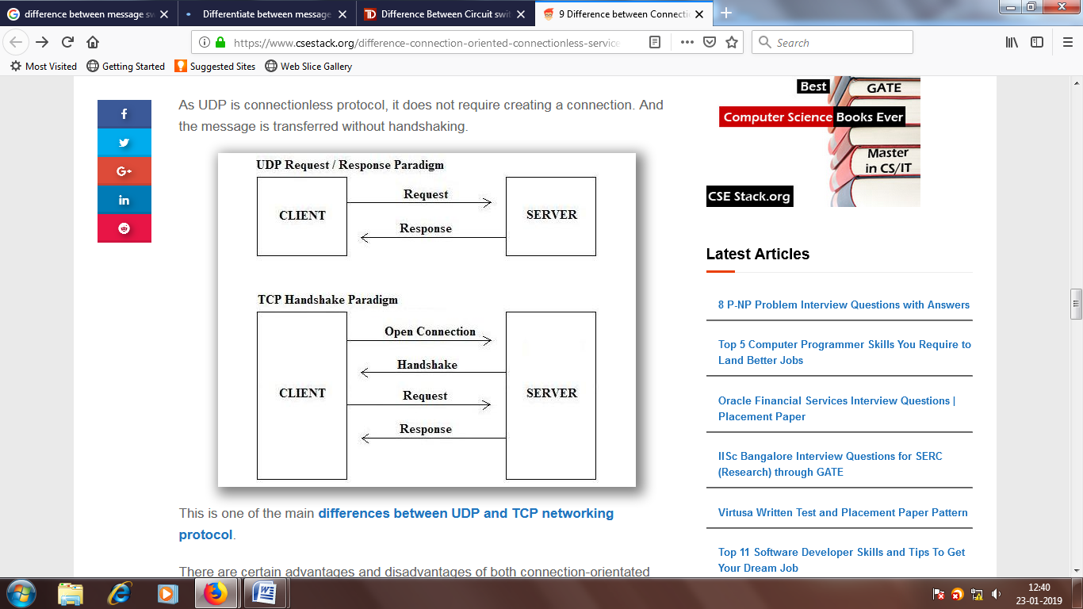

This is one of the main [differences between UDP and TCP networking protocol](https://www.csestack.org/difference-tcp-udp-protocol/).

There are certain advantages and disadvantages of both connection-orientated and connectionless services.

**What are the Advantages and Disadvantages of Connection-Oriented Service:**

**Advantages:**

* It is reliable.
* All the packets follow the same path to the destination.

**Disadvantages:**

* Handshaking is required before sending an actual data packet over the internet.
* Requires additional header parameter to ensure reliable communication between sender and receiver. So, it has extra overhead.
* Header size of the packet is bigger than connectionless protocol.

**What are the Advantages and Disadvantages of Connectionless protocol:**

**Advantages:**

* It sends the packet without handshaking.
* It is faster than connection-oriented protocol.
* The header size of the packet is smaller as compared to the packets in connection-oriented services.

**Disadvantages:**

* It is not reliable and cannot ensure the data transmission to the destination.
* Packets decide the route while transmission based on the network congestion.
* It does not have a fixed path.
* Different packets do not necessarily follow the same path.

**When to Use Connection-Oriented Protocol?**

If you need reliable communication between sender and receiver, connection-oriented services are more useful.

**Example:** We use email for communication. If we are sending an email to another recipient, it should be delivered. In this case, the connection-oriented protocol is more reliable to use.

**When to use Connectionless protocol?**

If we are more concern about the packet transmission speed than reliability, connectionless service is more useful.

**Example:** If we are developing video streaming website, we need a faster connection to stream without buffer delay. In this case, the connectionless protocol is more useful.

Domain name server (DNS) uses connectionless service protocol (UDP) for the domain and IP resolution.

**Wrapping Up…**

This is all about the difference between connection-oriented and connectionless services and protocols. I have explained it with the TCP and UDP example.

Moreover, each node (receiver and sender) have a hierarchy of networking layers. At each node, each layer filters and parses the message before sending it to next node. For more detail and to know how does it work, you can read  [7 Layers of OSI Model in Networking](https://www.csestack.org/7-layers-of-osi-model-in-networking/).

If you have any doubt or any point to discuss, let’s see you in the comment.

| **Sr. No.** | **Function** | **Message Switching** | **Circuit Switching** | **Packet Switching** |
| --- | --- | --- | --- | --- |
| 1. | Concept | In message switching, each switch stores the whole message and forwards it to the next switch. Although, we don't see message switching at lower layers, it is still used in some applications like electronic mail (e-mail). | When you or your computer places a telephone call, the switching equipment within the telephone system seeks out a physical path all the way from your telephone to the receiver’s telephone. This technique is called circuit switching. | With this technology, packets are sent as soon as they are available. |
| 2. | Store and forward transmission | Yes | No | Yes |
| 3. | Terminal | Telegraph, teletype | Telephone, modem | Computer |
| 4. | Information representation | Morse, Baudot, ASCII | Analog Voice or PCM digital voice | Any binary information |
| 5. | Transmission system | Digital over various media | Analog and digital over various media | Digital over various media |
| 6. | Addressing | Geographical addresses | Hierarchical numbering plan | Hierarchical address space |
| 7. | Routing | Manual routing | Route selected during call setup | Each packet routed independently |
| 8. | Multiplexing | Character multiplexing, message multiplexing | Circuit multiplexing | Packet multiplexing shared media across networks |
| 9. | Basic User and Network | Transmission of telegrams (Telegraph network) | Bidirectional real time transfer of voice signals (Telephone network) | Datagram and reliable stream service between computers (Internet). |
| 10. | Call setup | No | Required | Not needed |
| 11. | Dedicated physical path | Not required | Yes | No |
| 12. | Packets arrive in order | - | Yes | No |
| 13. | Each packet follows the same route | - | Yes | No |
| 14. | Bandwidth available | - | Fixed | Dynamic |
| 15. | Time of possible congestion | - | At setup time | On every packet |
| 16. | Potentially wasted Bandwidth | - | Yes | No |
| 17. | Charging | - | Per minute | Per packet |